AI ASSISTANT
LAB ASSIGNMENT:6.4
Name:srija
2303A52412
Batch 44
Task 1: Student Performance Evaluation System
Prompt: Initialize the attributes: name, roll_ number, and marks using the constructor
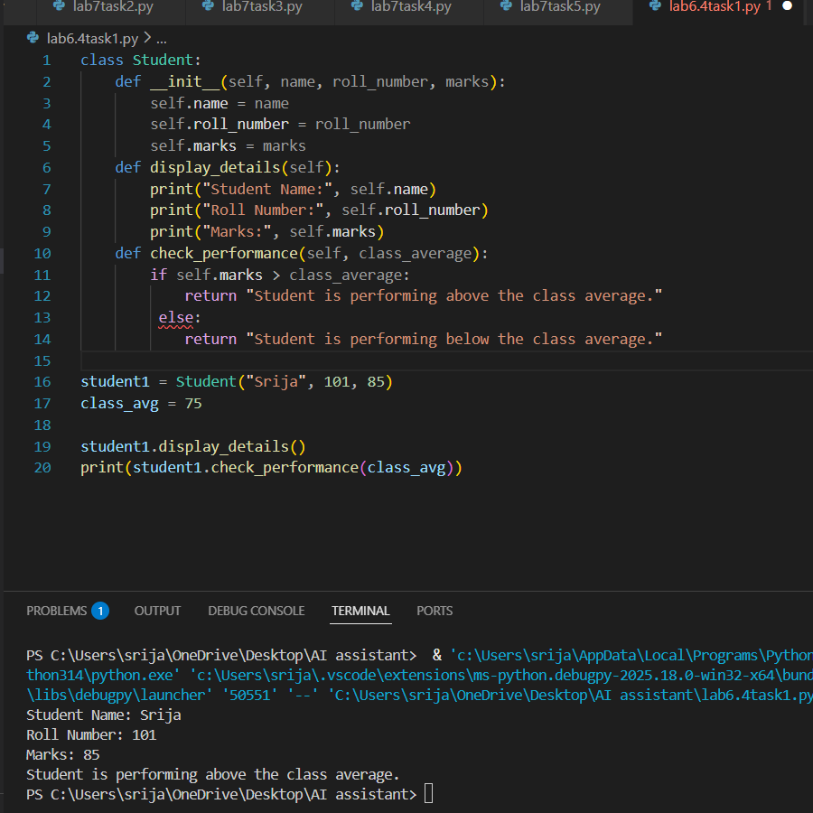
Task 2: Data Processing in a Monitoring System
Prompt: Write a Python for loop to iterate over a list of integers representing sensor readings.
Use the modulus operator (%) to identify even numbers.
Inside the loop, apply an if-else condition to check whether the number is even.

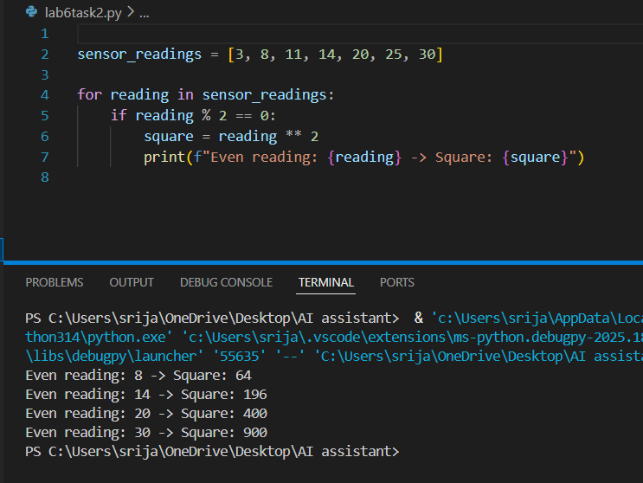
Task 3: Banking Transaction Simulation
Scenario
You are developing a basic banking module that handles deposits and
withdrawals for customers.
Task Description
Create the structure of a Python class named BankAccount with
attributes:
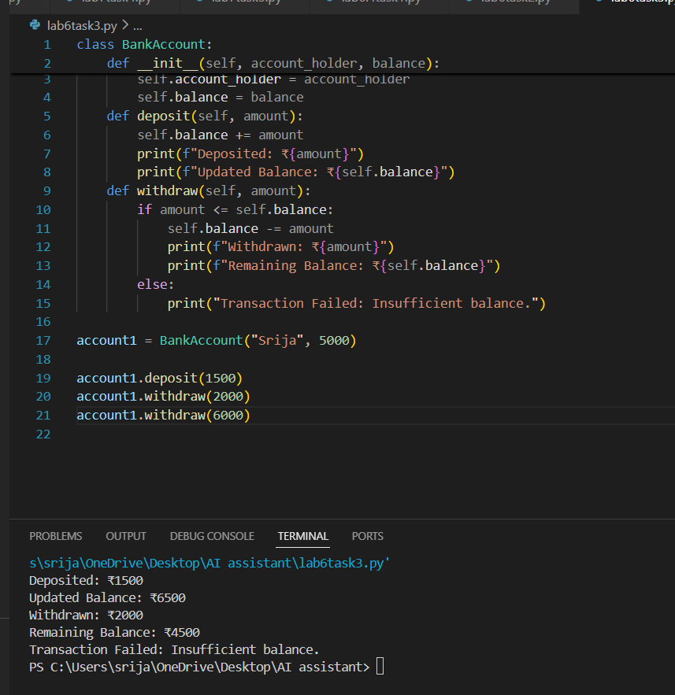
Task 4: Student Scholarship Eligibility Check
Scenario
A university wants to identify students eligible for a merit-based
scholarship based on their scores.
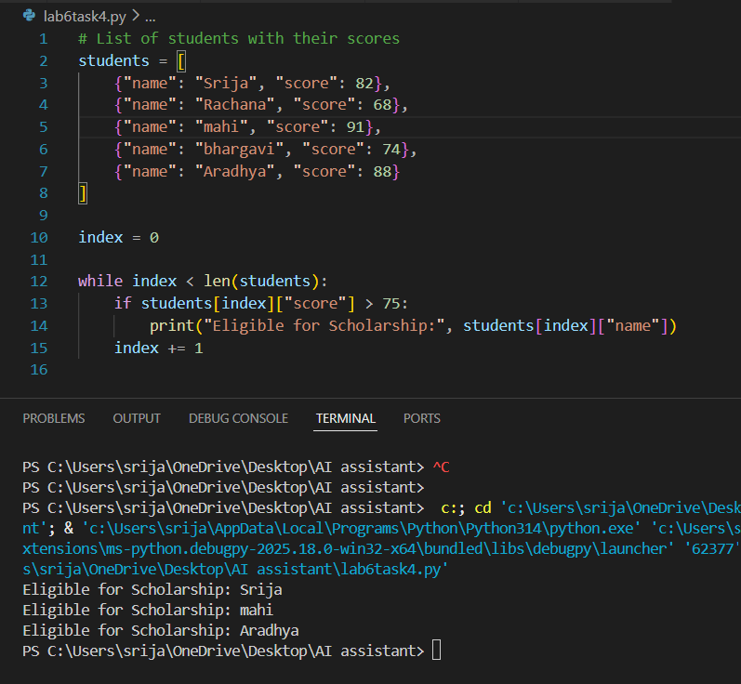
Task 5: Online Shopping Cart Module
Prompt: Begin writing a Python class named ShoppingCart with:
• An empty list to store items (each item may include name, price,
quantity)
